**MongoDB Shard Configuration**

**References:** <http://docs.mongodb.org/master/MongoDB-Manual-master.pdf>

[**http://www.10gen.com/presentations/mongosv-2011/how-and-when-to-scale-mongodb-with-sharding**](http://www.10gen.com/presentations/mongosv-2011/how-and-when-to-scale-mongodb-with-sharding)

**This document is assumes knowledge of MongoDB replication.**

A mongodDB shard is the description of adding additional servers for scaling read and write performance. In a production envirionment , replica sets are sharded. Additional components such as a backup server and replication across data centers which are still relevant are not covered in this document.

A sharded production MongoDB database environment looks like:

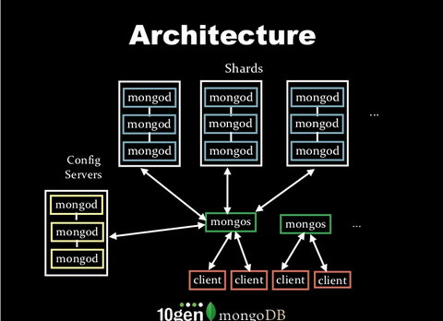

A MongoDB shard consists of:

1. 3 config servers in the yellow boxes on the bottom left You need 3 to keep a reliable cluster state. 3 provides a majority vote to determine correct data. If this data is corrupted or unstable the cluster is unusable and data may become unrecoverable. If there is 1 config server and the config server crashes the cluster is unusable(need to test for data loss and downtime).
2. 9 or more mongod instances to hold cluster data in the blue boxes. In a normal production environment each of the mongod instances is a replica set.
3. One or more mongos instances in the green boxes
4. Clients which if implemented as REST servers are the orange boxes.

**Amazon AWS Mongo sharded replica set setup:**

This is a representation of a fully replicated Mongo Cluster setup. The cluster is first setup manually then automated in later documents using a combination of bash shell scripts, Puppet for configuration and Apache whirr for instance launching.

Start 3 replica sets on 3 different servers then add 6 more VM servers to reach 9 servers for a complete production ready replica set. Configure the mongos and 3 configuration servers.

Run the following script on each server/VM where you want 3 replica set processes:

Run the following script on each server/VM for the full deployment of 9 servers: